Name: Nawal Fatima
Roll no: 94
Section: ________
University: Superior University, Lahore
Lab 1: Introduction to AI & Paradigms

Introduction
Is lab mein hum ne symbolic (rule-based) AI aur probabilistic (data-driven) AI ka farq dekha. Scholarship screening ka chhota prototype banaya jisme 'Review' ka matlab hai human reviewer ke liye flag, award decision nahi. Saari thresholds synthetic lab assumptions hain aur probability values invented demo inputs hain; koi model train nahi hua, is liye ye accuracy experiment nahi balki behavior comparison hai.

Task 1: AI Timeline
Year | Event | Significance | Source
1950 | Turing ka paper 'Computing Machinery and Intelligence' | Imitation game ka idea diya, jo machine intelligence ko behavior se parakhne ka pehla mashhoor test bana. | A. M. Turing, Mind, vol. 59, 1950
1956 | Dartmouth Summer Research Project on AI | Yahin 'Artificial Intelligence' ek research field ke taur par shuru hua. | McCarthy, Minsky, Rochester, Shannon, 1955 proposal
1974-1980 (AI winter) | First AI winter, Lighthill Report (1973) ke baad funding cuts | Over-promised results ki wajah se funding aur expectations gir gayin, yani hype aur evidence ka gap nazar aya. | Lighthill, 'Artificial Intelligence: A General Survey', 1973; Russell & Norvig, AIMA
1997 | IBM Deep Blue ne Garry Kasparov ko chess match mein haraya | Dikhaya ke bohat zyada compute aur search se ek narrow task mein world champion ko harana mumkin hai. | IBM Research / Campbell et al., Artificial Intelligence, 2002
2012 | AlexNet ne ImageNet competition jeeta (modern compute/data milestone) | GPUs aur bade labelled dataset (ImageNet) ne deep learning ko practical bana diya. | Krizhevsky, Sutskever, Hinton, NeurIPS 2012
Note: sources ko apni reference style mein final check kar lena.

Task 2: Rule-based Scholarship Checker
Purani conditions (score >= 70 aur documents complete) rakhi gayi aur 2 nayi named conditions add ki gayin: attendance_ok (attendance >= 75) aur community_ok (community_hours >= 10). Ye thresholds synthetic lab assumptions hain.
[ VS 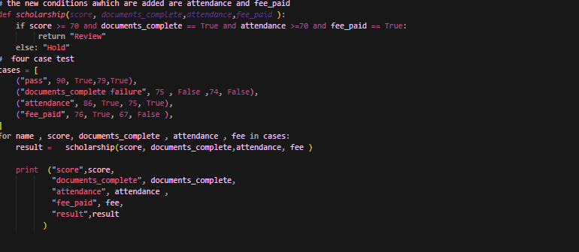

Test cases kaise chune: 1 pass case, har nayi condition ke liye 1 failure case (attendance aur community hours), aur 1 boundary case jo exact thresholds (70, 75, 10) par >= ka behavior check karta hai.
Expected output:
Case | Input | Expected | Reason
pass | 85, True, 90, 15 | Review | all conditions met
attendance_fail | 85, True, 60, 15 | Hold | attendance below 75
community_fail | 85, True, 90, 5 | Hold | community hours below 10
boundary | 70, True, 75, 10 | Review | all conditions met (>= boundary)

Actual output:
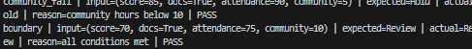
Chaaron cases mein expected aur actual result match karte hain (PASS).

Rule vs Threshold Comparison
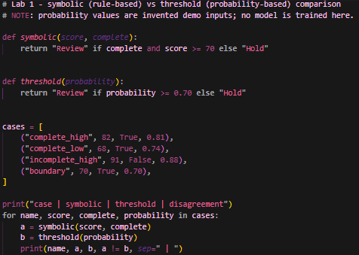

Output:
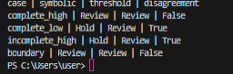

Case | Symbolic | Threshold | Disagree? | Kaunsi condition explain karti hai
complete_high | Review | Review | False | Dono conditions meet
complete_low | Hold | Review | True | Score 68 < 70, rule ne rok diya; probability 0.74 >= 0.70
incomplete_high | Hold | Review | True | Documents incomplete, threshold ko iski khabar nahi
boundary | Review | Review | False | 70 aur 0.70 dono par >= pass

Edge Case / Failure Analysis
Input: incomplete_high (score 91, documents incomplete, probability 0.88).
Observed behavior: symbolic = Hold, threshold = Review.
Likely cause: threshold rule sirf probability dekhti hai, document completeness uski input hi nahi hai. High score ke bawajood incomplete application flag ho gayi.
Improvement: probability rule ke saath documents_complete ka explicit check lagao (hybrid), aur human review ko final authority rakho.
Boundary test: score 69 aur probability 0.69 karne par dono Hold dete hain, yani threshold ke bilkul neeche dono rules same behave karte hain. Isolation se pata chala ke asal farq extra conditions (documents) ka hai, threshold ka nahi.

Task 3: Conversational Test vs General Intelligence
Conversational test (Turing Test) sirf ye observe karta hai ke kya machine ke jawab insaan jaise aur convincing lagte hain. Ye ye prove nahi karta ke machine documented rule follow kar rahi hai, sahi reasoning kar rahi hai, ya general intelligence rakhti hai. Fluent jawab aur sahi jawab alag cheezein hain.
Fluent but incorrect example: scholarship assistant kahe 'Aapki application strong hai (score 91), is liye Review ke liye bhej di gayi', jabki documents incomplete hain aur rule ke mutabiq Hold hona chahiye tha. Jawab convincing hai lekin rule ke khilaf.
Reliable task performance ka additional test: labelled applications (ground-truth outcomes ke saath) ka ek held-out set lo aur check karo ke assistant har case mein documented rule (complete + score >= 70) ke mutabiq flag karta hai ya nahi, aur accuracy aur galtiyon ke types record karo. Historical claims (Turing 1950) ke liye sources upar timeline mein diye hain.

Reflection
What did you learn today? Symbolic rules traceable hote hain, data-driven threshold complex patterns pakad sakta hai lekin uski logic hidden hoti hai.
How will you apply this? Real system mein rules aur probability dono ko mila kar (hybrid) use karungi, aur human review rakhungi.
What failed or surprised you? Incomplete application par high probability ka Review dena.
What would you do differently? Pehle test cases predict karungi aur validated data par threshold choose karungi.

Responsible Practice
Saari values synthetic hain. Real scholarship decision ke liye validated data, clear policy ownership aur human review zaroori hain. Marketing claims aur demonstrated capability ko alag rakhna chahiye.

